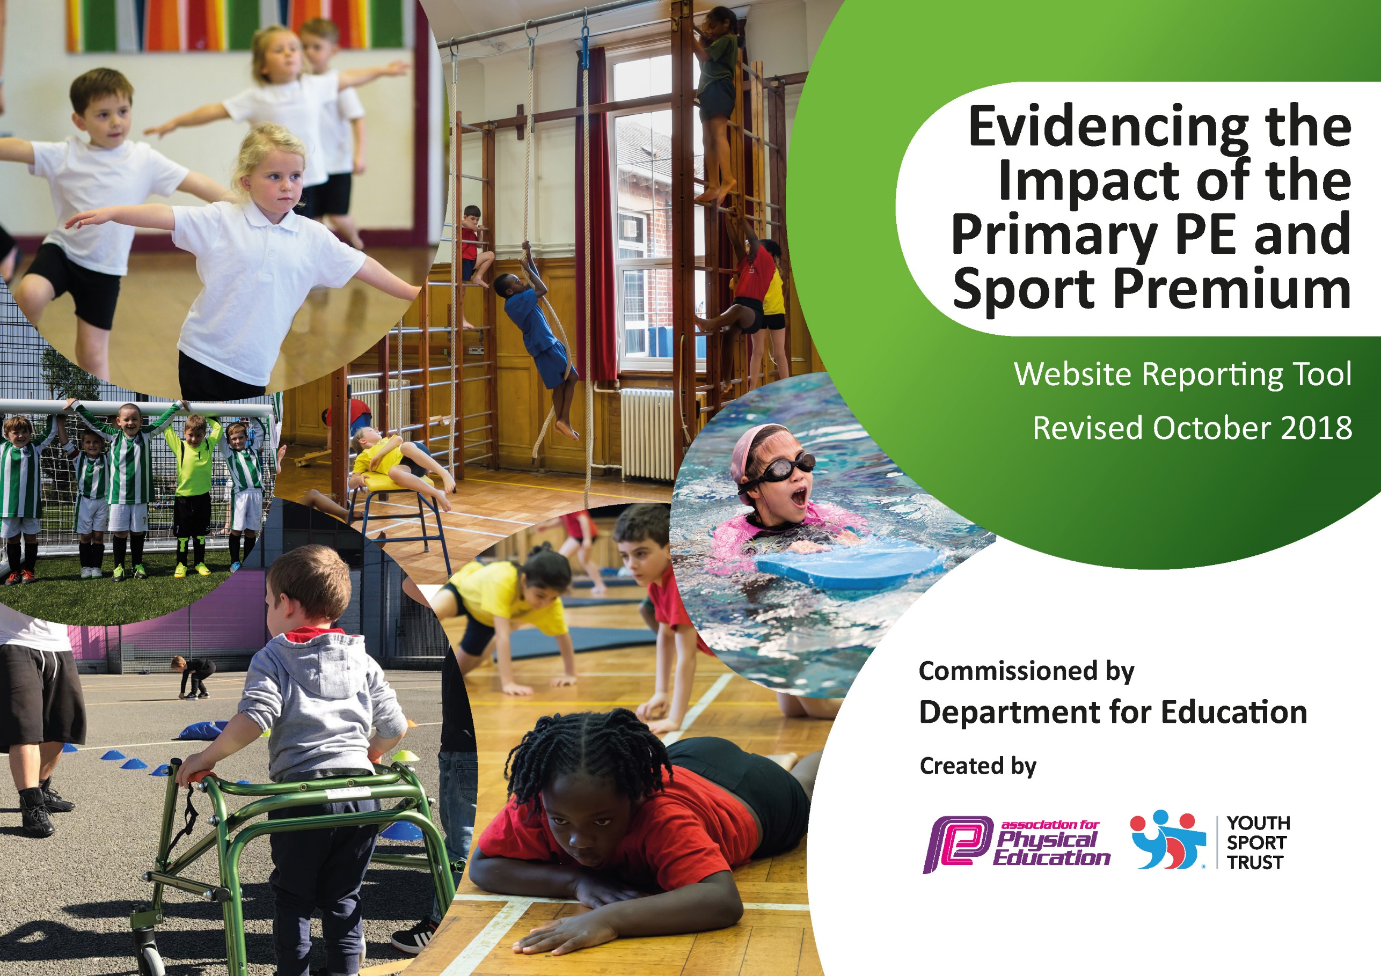
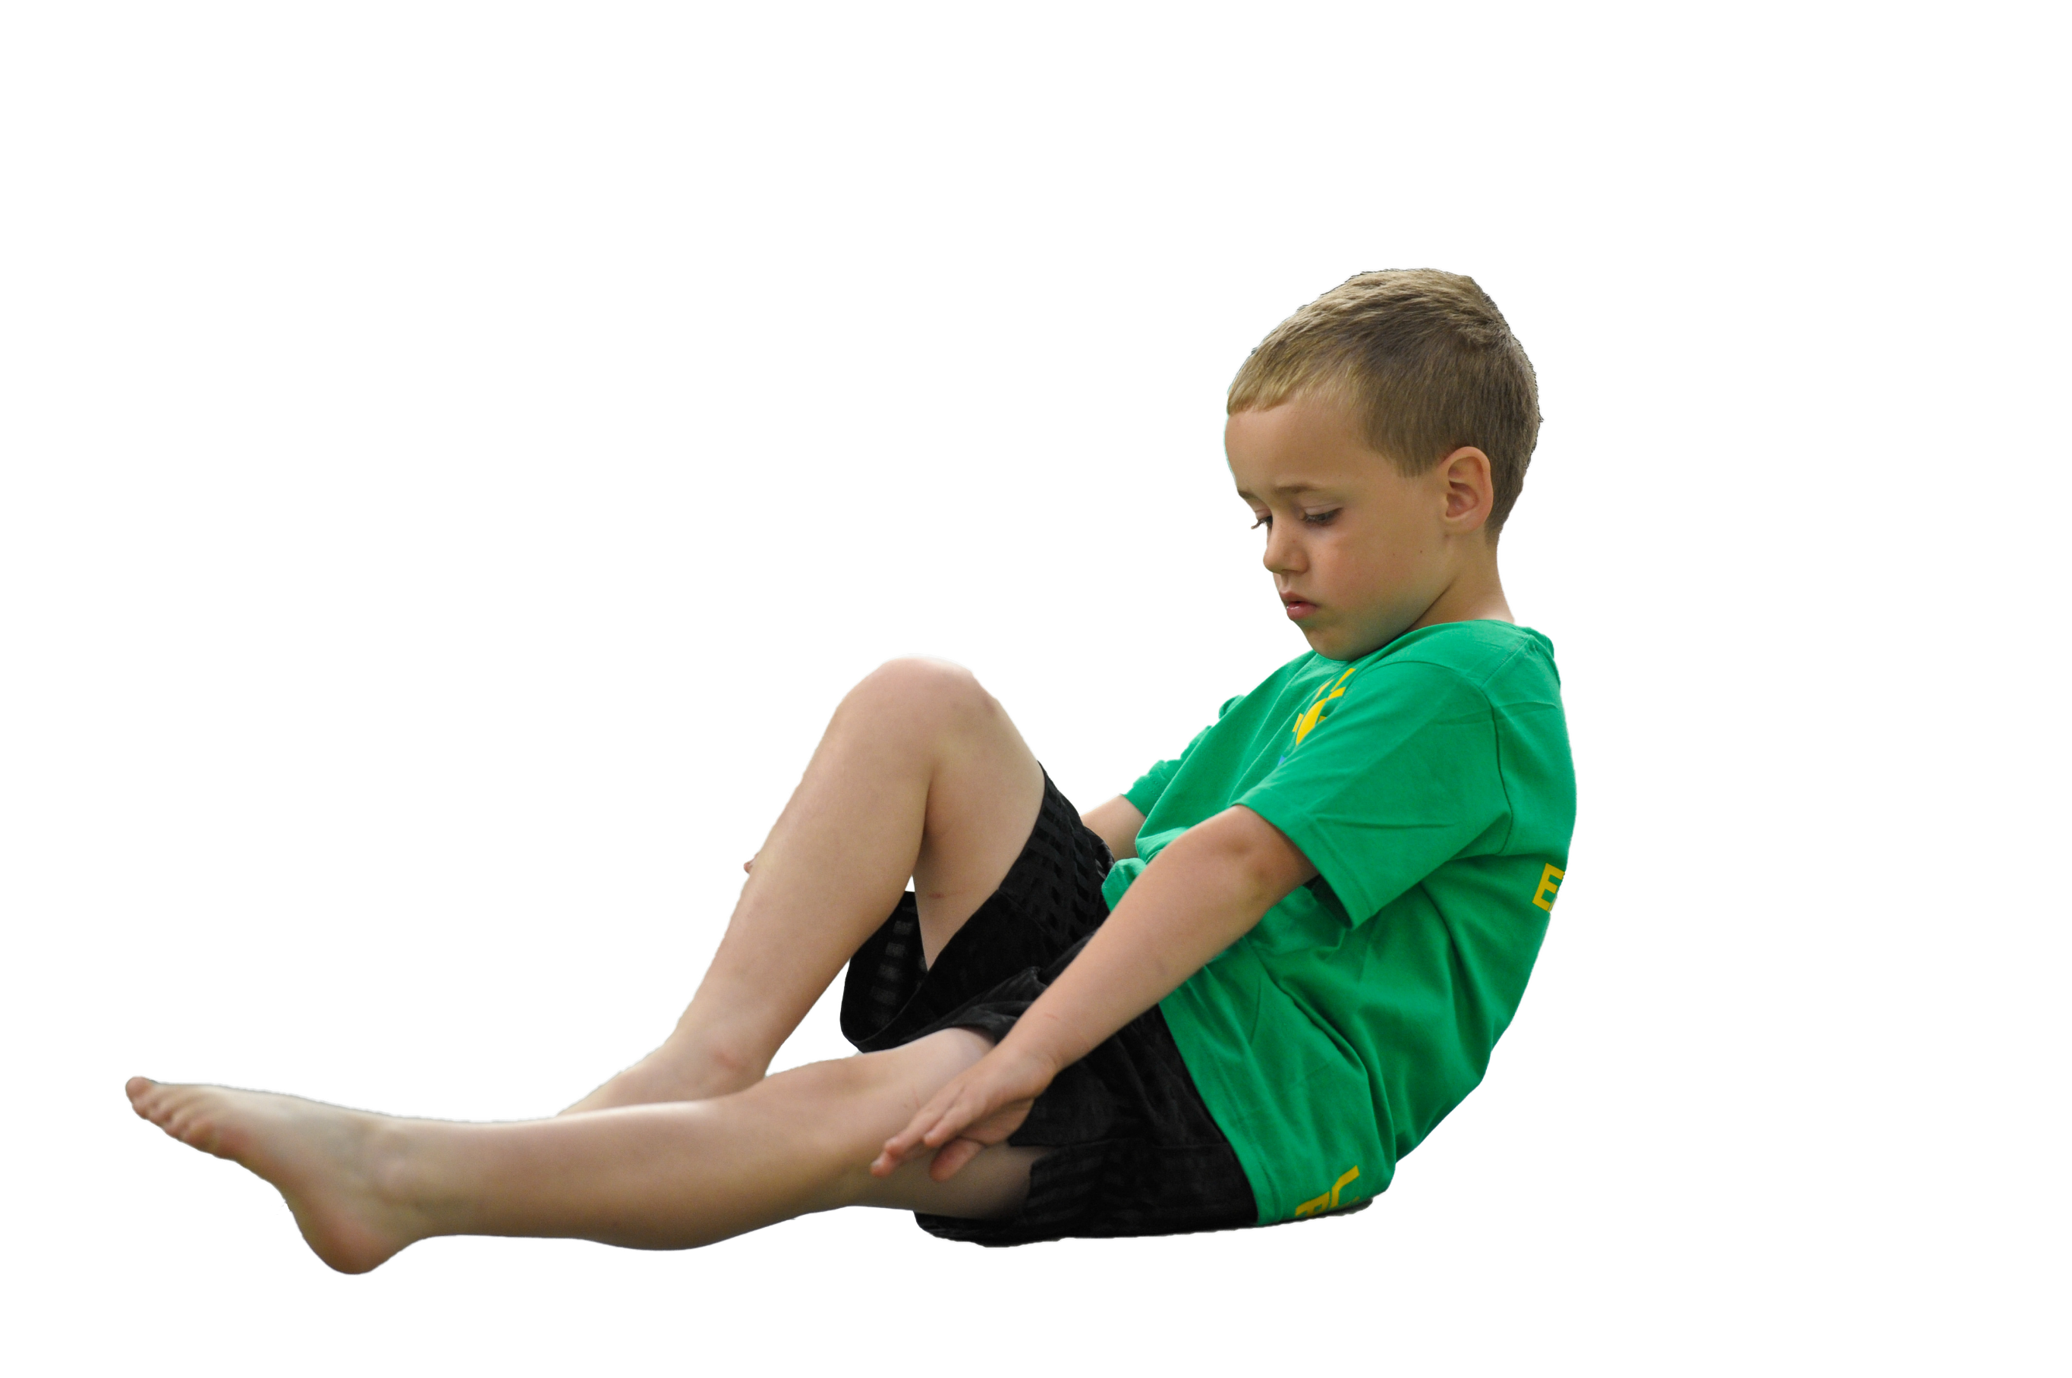
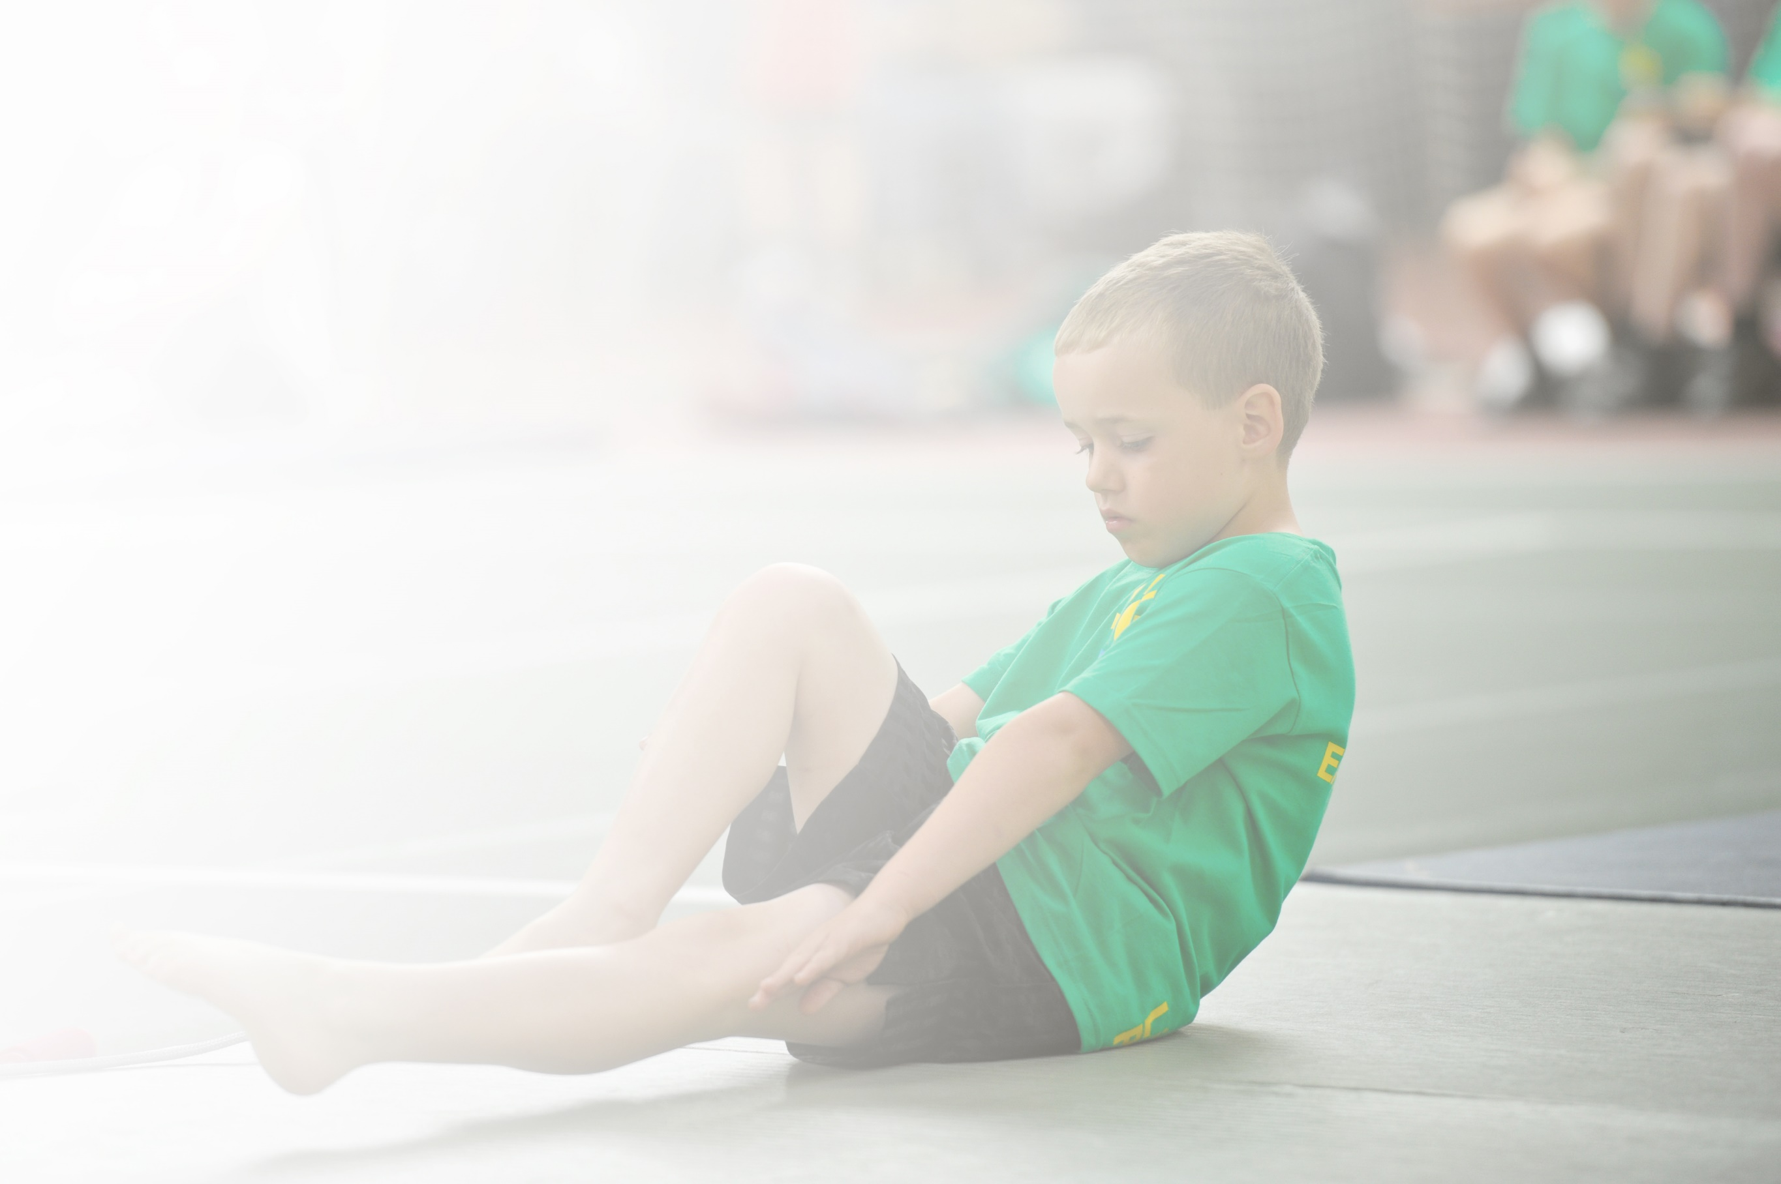
Schools must use the funding to make additional and sustainable improvements to the quality of Physical Education, Sport and Physical Activity (PESPA) they offer. This means that you should use the Primary PE and Sport Premium to:

- Develop or add to the PESPA activities that your school already offer
- Build capacity and capability within the school to ensure that improvements made now will benefit pupils joining the school in future years

Please visit gov.uk for the revised DfE guidance including the 5 key indicators across which schools should demonstrate an improvement. This document will help you to review your provision and to report
your spend. DfE encourages schools to use this template as an effective way of meeting the reporting requirements of the Primary PE and Sport Premium.

We recommend you start by reflecting on the impact of current provision and reviewing the previous
spend. Under the Ofsted Schools Inspection Framework, inspectors will assess how effectively leaders use the Primary PE and Sport Premium and measure its impact on outcomes for pupils, and how effectively governors hold them to account for this.

Schools are required to publish details of how they spend this funding as well as on the impact it has on pupils’ PE and sport participation and attainment by the end of the summer term or by 31 July 2019 at the
latest.
We recommend regularly updating the table and publishing it
on your website throughout the year, as evidence of your
ongoing review into how you are using the money to
secure maximum, sustainable impact. To see an
example of how to complete the table please
click HERE.

Support for review and reflection - considering the 5 key indicators from DfE, what development needs are a priority for your setting and your students now and why? Use the space below to reflect on previous spend, identify current need and priorities for the future.

Key achievements to date: | Areas for further improvement and baseline evidence of need:
A sound CPD programme set up and now well established to help staff increase knowledge and skills of a variety of sports.  Well attended extra-curricular clubs  Effective use of the 2 hours PE given. | Getting the less active children active at various times of the day.  Encourage more children to attend extra-curricular clubs.  Achieve the Bronze Sports Award  Complete a whole school survey to ask the children what sports they want to learn.  Improve reporting on sporting events.

Meeting national curriculum requirements for swimming and water safety | Please complete all of the below:
What percentage of your current Year 6 cohort swim competently, confidently and proficiently over a distance of at least 25 metres?  N.B. Even though your children may swim in another year please report on their attainment on leaving  primary school. | 90%  26/29 children
What percentage of your current Year 6 cohort use a range of strokes effectively [for example, front crawl, backstroke and breaststroke]? | 90%  26/29 children
What percentage of your current Year 6 cohort perform safe self-rescue in different water-based situations? | 90%  26/29 children
Schools can choose to use the Primary PE and Sport Premium to provide additional provision for swimming but this must be for activity over and above the national curriculum requirements. Have you used it in this way? | Yes/No

Action Plan and Budget Tracking
Capture your intended annual spend against the 5 key indicators. Clarify the success criteria and evidence of impact that you intend to measure to evaluate for students today and for the future.

Academic Year: 2018/19 | Total fund allocated: £17,787 | Date Updated: July 2019
Key indicator 1: The engagement of all pupils in regular physical activity – Chief Medical Officer guidelines recommend that primary school children undertake at least 30 minutes of physical activity a day in school |  |  |  | Percentage of total allocation:
 |  |  |  | 8%
School focus with clarity on intended impact on pupils: | Actions to achieve: | Funding allocated: | Evidence and impact: | Sustainability and suggested next steps:
Ensuring children take part in physical activity during the school day whilst improving their muscular endurance and cardiovascular system. | Head Teacher to timetable each class to have a Daily Mile slot. The children are to attempt completing a mile by walking, jogging or running each day.  PE lead to deliver KS2 dinner time activities once a week.  Welfare assistants to have training to help engage more children to be more active during lunchtimes. | £ 500  £1000 equipment | The daily mile was not introduced but discussed on how we can fit it into the timetable.  Each class were given skipping ropes which are used at lunchtimes by all children.  PE lead manages to do one 15-minute session per week at lunch to engage those children who are not physically active.  Training for welfare assistants did not happen. | Time for the PE lead to engage children can continue and other members of staff on duty can take this role on too.  Training for dinner staff needs to happen for the children to have the opportunity to be physically active at lunchtime.  This will then cover 15 minutes out of the recommended 30. The other 15 minutes can be built into curriculum time.  Make enquiries about using Edge Hill students to run club at lunchtimes or after school.  Seek advice on how other school complete daily mile and not impact on the school day too much.
Key indicator 2: The profile of PESSPA being raised across the school as a tool for whole school improvement |  |  |  | Percentage of total allocation:
 |  |  |  | 30%
School focus with clarity on intended impact on pupils: | Actions to achieve: | Funding allocated: | Evidence and impact: | Sustainability and suggested next steps:
Highlight achievements in PE and school sport to encourage greater participation.  Keep children healthy and active, improve communication, improve leadership skills, improve discipline, increase fun and increase self-esteem. | PE lead to arrange a new Sports display with updates made throughout the year. Information to show children about sports that are offered as extracurricular.  Use Year 6 children as play leaders at break times to help improve younger children’s perceptions of PE.  Purchase equipment for outdoor play times.  Employ Commando Joe company from January to help build children’s self-esteem, discipline and team work. | £1000 equipment  £4000 Commando Joe | Sports board used well and set along the corridor where children wait for lunch  Year 6 have worked well with the younger children and have introduced them to new games over the year.  Commando Joe has had a positive impact on behaviour and discipline. The children are more ready to learn and have enjoyed having these sessions. Team work has increased and confidence in the quieter children has been improved also. We will continue to have this until December 2019 | The sports board needs to be updated more often. There needs to be more evidence from each class and what they have been learning in PE.  Train up next year’s Year 6 to be play leaders so that they can take on activity leader roles from September.  Budget to get more playtime equipment to keep baskets well stocked for play times.  Take ideas and advice from Commando Joe so some of the ideas and activities can be carried on when the contract ends.

Key indicator 3: Increased confidence, knowledge and skills of all staff in teaching PE and sport |  |  |  | Percentage of total allocation:
 |  |  |  | 22%
School focus with clarity on intended  impact on pupils: | Actions to achieve: | Funding  allocated: | Evidence and impact: | Sustainability and suggested  next steps:
Improved quality of children’s physical education to ensure that they are all competent and confident.  Improved role modelling of heathy, active lifestyle behaviours by all school staff.  CPD programme set up to enhance teachers’ skills and knowledge of various sports across the school. | Hiring of sports coaches to work alongside teachers and teaching assistants in a CPD role.  All staff twilight to ensure every member of staff has a knowledge how to deliver PE and Sport.  Explain how to use plans  PE lead to provide updates on school sports in staff meetings over the year.  PE subject lead to do some drop-in sessions on teachers to check skill level is good and offer members of staff to observe PE lessons if they want.  PE lead to complete a staff audit around PE in school. | £4000 – sports coaches. | Lesson plans are provided by an outside company and all staff have access to these. PE lead ensures that these are updated regularly.  CPD was participated in in each year group with every teacher having at least two blocks over the year. The knowledge of the staff in the new sports has improved greatly.  Staff meeting was postponed for Autumn term. | CPD to continue next year as there is a lot of staff movement to new year groups.  Ask staff before the start of the new year what areas of the curriculum they need help with. Need more rigorous observations of CPD sessions.  Teachers can call on previous year group teacher for help in the areas of PE they are struggling with if they are not receiving CPD for that area.
Key indicator 4: Broader experience of a range of sports and activities offered to all pupils |  |  |  | Percentage of total allocation:
 |  |  |  | 18%
School focus with clarity on intended  impact on pupils: | Actions to achieve: | Funding  allocated: | Evidence and impact: | Sustainability and suggested  next steps:
To provide a range of sports and physical activity experiences to allow ALL children to acknowledge their strengths and realise their areas for improvements.  To allow children to make an informed choice about sport and physical activities available as extra-curricular.  To allow those disadvantaged pupils to participate in extra-curricular subjects. | Hiring specialist sports coaches to offer a wide variety of curricular and extra-curricular sports clubs, such as:  Football, Netball, Archery, Rugby, Tennis, Dance, Gymnastics, Handball, Running, Judo, Multiskills, Dodgeball  Allow money to be used to for these children to have lessons outside school | £3000  £250 |  | Make enquiries about using Edge Hill students to run clubs before and after school to give children a wider range of sports to enjoy.
Key indicator 5: Increased participation in competitive sport |  |  |  | Percentage of total allocation:
 |  |  |  | 4%
School focus with clarity on intended  impact on pupils: | Actions to achieve: | Funding  allocated: | Evidence and impact: | Sustainability and suggested  next steps:
Increase opportunities for children to apply their skills in a competitive environment, encouraging confidence and determination. | Develop a programme of competitive events across the school year.  To enter tournaments when they are being delivered.  To help organise events and tournaments within the new cluster of schools we have entered.  Create letters and risk assessments for tournaments  Take children to tournaments.  Have a competitive sports day | £500 – transport costs  £150 – sports coach for Sports Day  £80 – medals for sports day. | Competitive events not set up at the beginning of the year and participated in on an ad hoc circumstance.  Used new Parent App to send permissions for competitions off site – very successful.  Sports day very successful in two parts – field events and track events being separated so that all children could participate in both and get scores.  Those competitions that we did manage to enter externally were enjoyed. Children were given the opportunity to experience a competitive tournament, without much pressure. The children enjoyed being out of school and seemed to appreciate the competitive nature. These outcomes were celebrated in school assemblies.  Not as many cluster competitions organised this year as St Helens offering a lot more. Some competitions cancelled because of bad weather and unable to be rearranged. | Join the SHAPES SLA to ensure competitions are entered and get places at them – this will be at a cost of £950  Set up an in-house programme of events for intra-sports competitions one a term – invest in trophies.  A bank of risk assessments has been started.

