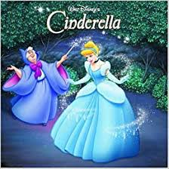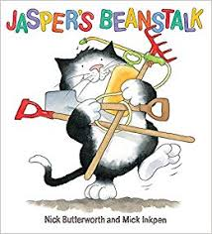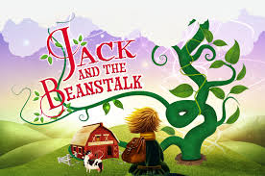 I

**Links to Fundamental British Values:**

**Mutual Respect and Tolerance-** Acknowledging the differences in Religious beliefs (learning about Islam)

**The rule of Law-** Children following the rules for their own health and safety

**Community Links and Cultural Capital:**

-Mission Statement Community Launch

- DEAR time and Reading Rocks Cafe

-Easter Crafts with Reeve Court

- Learning about Islam (Come & See)

**Links to home learning:**

**-** Reading in an unusual place home learning challenge

- Maths in the EYFS workshop for parents

**Spring Term 2**

**Magic Beans and Greens!**

**Impact**

Children will become knowledgeable about the format of traditional tales and will be able to talk about how plants change over time and how to lead a healthy lifestyle This learning will be seen in all areas and the children will be able to recall their learning over time.

**Implementation**

Children will be taught using a combination of adult led activities and input alongside continuous child-initiated learning activities. Each child is assigned a Key Worker to facilitate their learning. All assessments will be completed in provision. Strong parental links will also be utilised to further the children’s learning.

**Development Matters Links (Intent)**

(direct teaching points highlighted, other DM links will be incidentally taught during child-initiated learning time)

**Making Relationships**

25. Take steps to resolve conflicts with other children eg finding a compromise

ELG4. They form positive relationships with adults and other children

**Self Confidence and Self-Awareness**

18. Confident to speak to others about own needs, wants and interests

**Managing feelings and Behaviour**

28. Beginning to negotiate and solve problems without aggression

**Listening and Attention**

25. Listen and do for a short span

**Understanding**

17. Follow a story without pictures or props

**Speaking**

34. Link statements and stick to a main theme or intention

**Moving and Handling**

49. Show increasing control over an object in pushing, patting, throwing, catching or kicking it

51. Handle tools, objects, construction and malleable materials safely

**Health & Self-Care**

32. Show understanding of need for safety when undertaking new challenges, considering and managing some risks

ELG1. Children know the importance for good health of physical exercise, and a healthy diet and talk about ways to keep healthy and safe.

**Reading**

27. Read words and simple sentences

30. Know that information can be retrieved from books and computers

**Writing**

10. Use some clearly identifiable letters to communicate meaning, represent some sounds in correctly and in sequence

12. Attempt to write short sentences in meaningful contexts

**Numbers**

39. Begin to use the vocabulary involved in adding and subtracting

40. Record using narks they can interpret and explain

**Shape, Space and Measure**

21. Begin to use mathematical names for solid 3d shapes and flat 2D shapes

25.Order 2 or 3 items by weight or capacity

28. Begin to use everyday language related to money

**People & Communities**

ELG1. Children talk about past and present events in their own

lives and in the lives of family members.

**The World**

ELG3. They make observations of animals and plants and explain why some things occur, and talk about changes**.**

**Technology**

12. Use ICT hardware to interact with age appropriate computer software

ELG2. They select and use technology for particular purposes.

**Exploring and Using Media and Materials**

24. Explore the different sounds of instruments

27. Gain understanding that different media can be combined to create different effects

**Being Imaginative**

20. Play co-operatively as a group to develop and act out a narrative

**Key Texts to be used:**