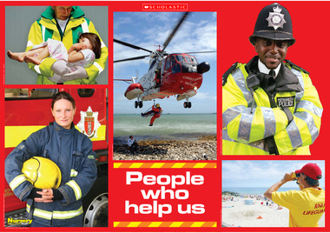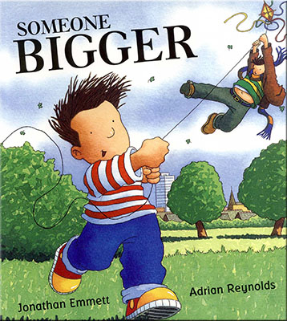 I

**Links to home learning:**

**-** Children will be asked to share their learning with their parents at an end of half term celebration within the classroom where the children can showcase their learning

- Family members invited in to talk about their roles in the home and in the work place.

- Maths in the EYFS workshop for Parents

**Development Matters Links (Intent)**

(Direct teaching points highlighted, other DM links will be incidentally taught during child-initiated learning time)

**Making Relationships**

19. Can play in a group extending and elaborating play ideas.

21. Keeps play going by responding to what others are saying or doing.

**Self Confidence and Self-Awareness**

15. Is more outgoing towards unfamiliar people and more confident in new social situations.

16. Confident to talk to other children when playing and will communicate freely about own home and community.

**Managing feelings and Behaviour**

22. Aware of own feelings, and knows that some actions and words can hurt others feelings.

25. Can usually adapt behaviour to different events, social situations and changes in routines.

**Listening and Attention**

19. Listens to others one to one or in small groups, when conversation interests them.

23. Is able to follow directions.

**Understanding**

12. Understands the use of objects.

13. Shows understanding of prepositions.

**Speaking**

26. Questions why things happen and gives explanations.

30. Builds up vocabulary that reflects the breadth of their experiences.

31. Uses talk in pretending that objects stand for something else in play.

**Moving and Handling**

41. Uses one-handed tools and equipment.

42. Holds pencil between thumb and two fingers no longer using whole-hand grasp.

44. Can copy some letters.

**Health & Self-Care**

24. Observes the effects of activity on the body.

25. Understands that tools and equipment have to be used safely.

31. Shows some understanding that good practices with regard to exercise, eating, sleeping and hygiene can contribute to good health.

**Reading**

16. Shows interest in illustrations and print in books and print in the environment.

17. Recognises familiar words and signs such as own name and advertising logos.

24. Hears and says initial sounds in words.

**Writing**

W3. Ascribes meaning to marks that they see in different places.

W4. Give meaning to marks they make as they draw, write and paint.

W7. Hears and says initial sounds in words.

**Numbers**

20. Compares two groups of objects, saying when they have the same number.

22. Separates a group of three or four objects in different ways, beginning to recognise the total is still the same.

23. Shows an interest in numerals in the environment.

24. Shows an Interest in representing numbers.

27. Recognises numerals 1 to 5.

28. Counts up to three or four objects by saying one number name for each item.

**Shape, Space and Measure**

15. Shows awareness of similarities of shapes in the environment.

16. Uses positional language.

18. Shows interest in shapes in the environment.

**People & Communities**

10 Show interest in different occupations and ways of life

**The World**

18. Talks about why things happen and how things work.

**Technology**

7. Shows skill in making toys work by pressing parts or lifting flaps to achieve effects such as sound movement or images.

**Exploring and Using Media and Material**

19. Uses various construction materials.

20. Beginning to construct, stacking blocks vertically and horizontally, making enclosures and creating spaces.

21. Joins construction pieces together to build and balance.

22. Realises tools can be used for a purpose.

**Being Imaginative**

11. Engages in imaginative role-play based on own first-hand experiences.

13. Use available resources to create props to support role-play.

**Community Links and Cultural Capital:**

-Focus for Chinese New Year

-Visits from the emergency services and other members of the community.

- Trip to the local CO-OP.

**Spring Term 1**

**People who help us.**

**Links to Fundamental British Values:**

**Mutual Respect-** Acknowledging the differences in Religious beliefs (learning about Islam)

**Individual Liberty-** Children setting their own dreams and goals for the future

**Impact**

Children will become knowledgeable about people who help them and the roles and responsibilities of the adults in the community.

**Implementation**

Children will be taught using a combination of adult led activities and input alongside continuous child-initiated learning activities. All assessments will be completed in provision.

**Key Texts to be used:**

 