 I

**Development Matters Links (Intent)**

(Direct teaching points highlighted, other DM links will be incidentally taught during child-initiated learning time)

**Making Relationships**

20. Initiate play offer cues to peers to join them.

22.Demonstrate friendly behaviour, initiating conversations and forming good relationships with peers and familiar adults.

**Managing Feelings and Behaviour**

22. Become aware of own feelings and know that some actions and words can hurt others’ feelings.

23. Begin to accept the needs of others and take turns and share resources, sometimes with support from others.

24. Show they can tolerate delay when needs are not immediately met and understand wishes may not always be met.

25. Try to adapt behaviour to different events, social situations and changes in routine.

**Self Confidence and Self-Awareness**

12. Select and use activities and resources with help.

15. Become more outgoing towards unfamiliar people and more confident in new social situations.

16. To talk to other children when playing and communicate freely about own home and community.

17. To ask adults for help.

**Listening and Attention**

19. Listen to others one to one or in small groups when conversation interests them.

**Speaking**

24. Retell a simple past event in the correct order.

29. Use vocabulary focused on objects and people that are of particular importance to them.

30. Build up vocabulary that reflects the breadth of their experiences.

**Understanding**

12. Gain understanding of the use of objects.

14. Respond to simple instructions, e.g. to get or put away and object.

**Moving & Handling**

34. Move freely in a range of ways.

35. Mount steps, stairs or climbing equipment using alternative feet.

36. Walk downstairs to feet to a step while carrying a small object.

38. Stand on one foot.

40. Draws lines and circles using gross motor movements

**Health & Self-Care**

23. Tell adults when they are hungry or tired, need a rest or want to play.

26. Gain more bowel and bladder control- attend to toilet needs themselves.

**Reading**

7. Enjoy rhyming and rhythmic activities.

10. Listen to and join in with stories/poems, 1:1 and also in small groups.

18. Looks at books independently.

18. Handles books carefully.

21. Hold books the correct way up and turn pages.

**Writing**

1. Distinguish between the marks they make.

2. Give meaning to marks as they draw and paint.

**Numbers**

13. Use some number names and number language spontaneously.

14. Use some number names accurately in play.

15. Recite numbers in order to 10.

17. Begin to represent numbers using fingers, marks on paper or pictures.

19. Show curiosity about numbers by offering comments/asking questions.

26. Recognise some numerals of personal significance.

**Shape Space and Measures**

14. Shows an interest in shape and space by playing with shapes or making arrangements with objects.

**People and Communities**

7. Show interest in the lives of people who are familiar to them.

8. Recall and talk about significant events in their own experience.

**The World**

16. Comment and ask questions about aspects of their familiar world such as the place where they live or the natural world.

**Technology**

3. Seek to acquire basic skills in turning on and operating some ICT equipment.

4. Operate mechanical toys e.g. turn knob on wind-up toy

5. Gain knowledge to operate simple equipment e.g. use remote control.

**Exploring and Using Media and Materials**

10. Enjoy joining in with dancing and ring games.

11. Sing a few familiar songs.

12. Begin to move rhythmically.

13. Imitate movement in response to music.

14. Tap out simple repeated rhythms

15. Explore and learn how sounds can be changed.

17. Understand that they can use lines to enclose a space and then begin to use these shapes to represent objects.

18. Begin to gain interest in and describe the texture of things.

**Being Imaginative**

5. Develop preferences for forms of expression.

6. Use movement to express feelings.

7. Create movement in response to music.

8. Sing to self and make up simple songs. 9. Make up rhythms.

10. Notice what adults do, imitating what is observed and then doing it spontaneously when the adult is not there.

11. Engage in imaginative role-play based on own first hand experiences.

15. Create simple representations of events, people and objects.

**Links to home learning:**

Parents will be asked to send in photos of their child and their families.

Library books will be sent home to share each week and a little activity relating to our topic.

**Links to Fundamental British Values:**

**Democracy:** Provide activities to promote lots of turn-taking and sharing of resources. Daily choice of story book/snack etc.

**Rule of Law:** Creating class rules, behaviour expectations, learning about right from wrong.

**Individual Liberty:** Talking about feelings.

**Mutual Respect:** Looking at similarities and differences in their likes and dislikes. Family photos.

**Autumn Term 1**

**We are all special**

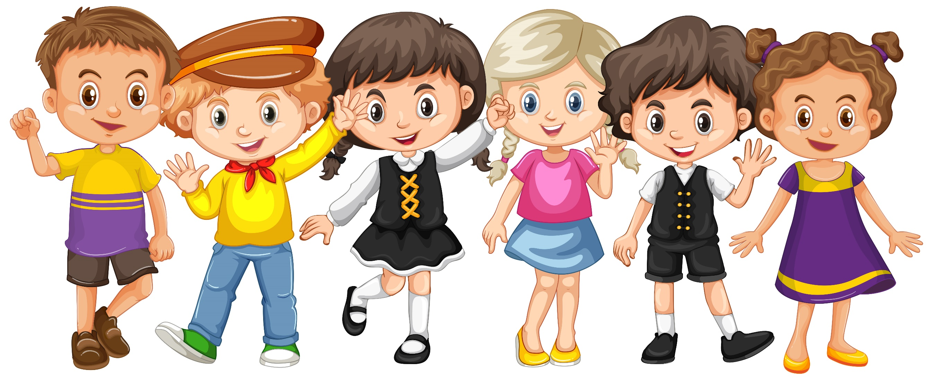

**Community Links and Cultural Capital:**

As the new school year begins we will be getting to know the children and do a baseline assessment. Once that is completed we will begin to plan around their interests. We will be following the phase one letters and sounds and give the children lots of opportunities to explore new things: musical instruments, resources, outdoor play equipment, stories, songs, rhymes and activities. Activities focused on their own lives and that of their community.

**Key Texts to be used:**

 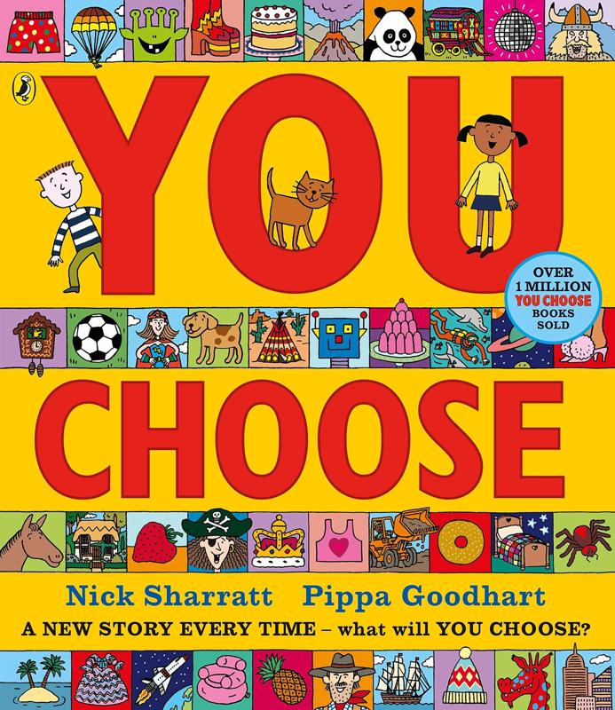

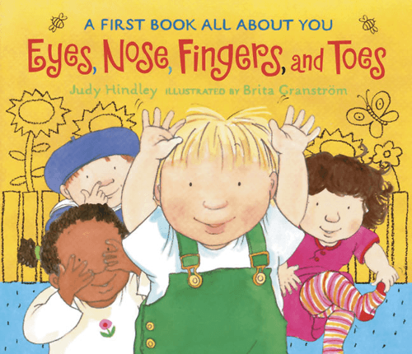 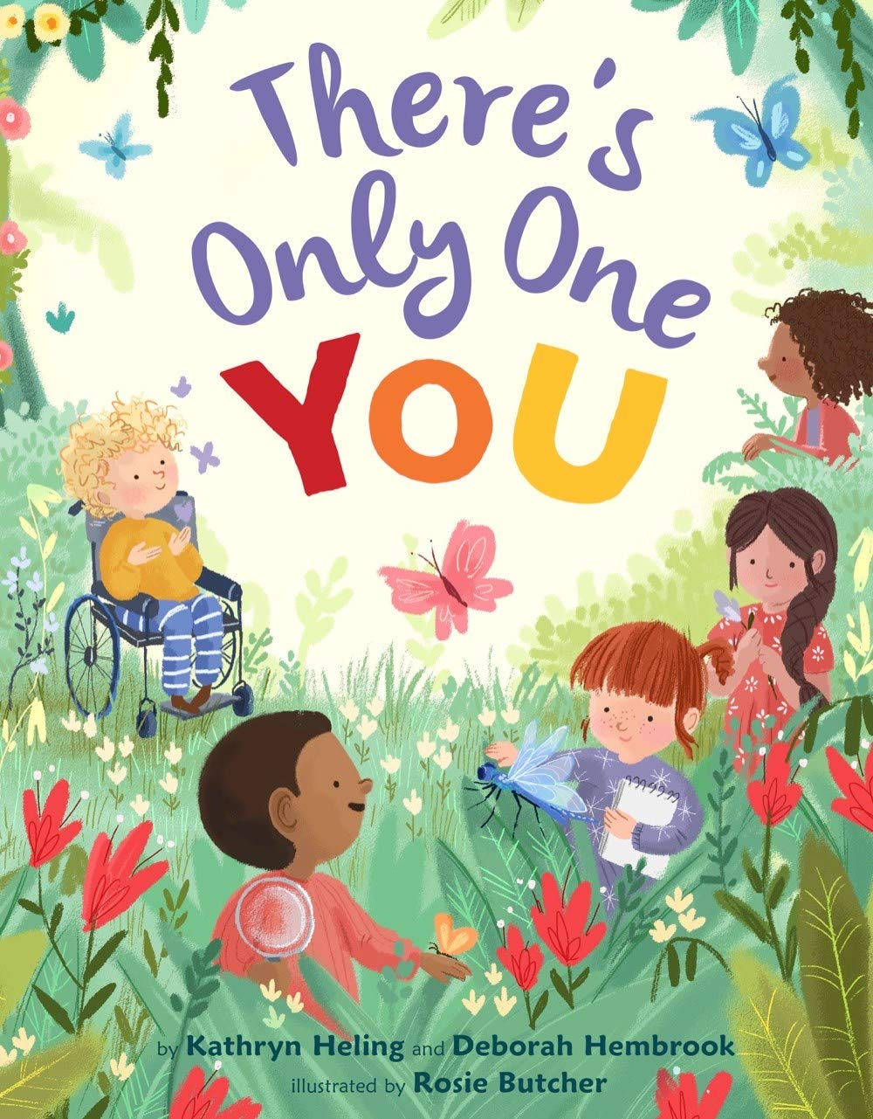

**Implementation**

Children will be taught using a combination of adult led activities and input alongside continuous child-initiated learning activities. All assessments will be completed in provision.

**Impact**

Children will gain confidence in their new environment. They will make friends and learn how to take turns and share resources. They will realise how special and individual they are.