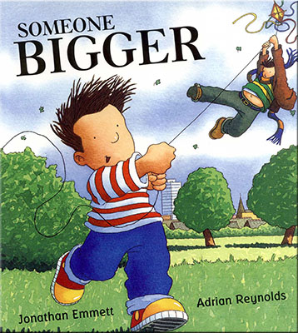 I

**Key Texts to be used:**

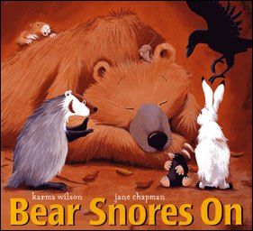 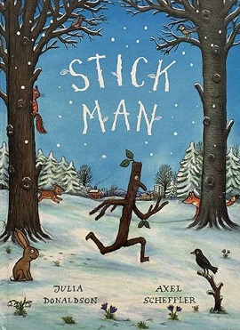

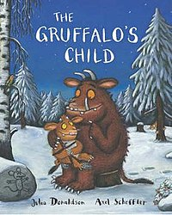 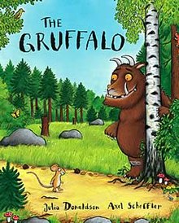

**Development Matters Links (Intent)**

(Direct teaching points highlighted, other DM links will be incidentally taught during child-initiated learning time)

**Making Relationships**

20. Initiate play offer cues to peers to join them.

22. Demonstrate friendly behaviour, initiating conversations and forming good relationships with peers and familiar adults.

**Managing Feelings and Behaviour**

23. Begin to accept the needs of others and take turns and share resources, sometimes with support from others.

24. Show they can tolerate delay when needs are not immediately met, and understand wishes may not always be met.

25. Try to adapt behaviour to different events, social situations and changes in routine.

**Self Confidence & Self-Awareness**

13. Welcome and value praise for what they have done.

14. Enjoy responsibility of carrying out small tasks.

15. Become more outgoing towards unfamiliar people and more confident in new social situations.

16. To talk to other children when playing, and communicate freely about own home and community**.**

**Listening and Attention**

19. Listen to others one to one or in small groups, when conversation interests them.

21. Join in with repeated refrains and anticipate key events and phrases in rhymes and stories.

**Speaking**

23. Begin to use more complex sentences.

24. Retell a simple past event in the correct order.

26. Question why things happen and give explanations

27. Use a range of tenses.

**Understanding**

12. Gain understanding of the use of objects.

14. Respond to simple instructions.

15. Begin to gain understanding of ‘why’ and ‘how’ questions.

**Moving and Handling**

34. Move freely in a range of ways.

37. Run and negotiate space, adjust speed and direction to avoid obstacles.

**Health and Self-Care**

23. Tell adults when they are hungry or tired, need a rest or want to play.

26. Gain more bowel and bladder control- attend to toilet needs themselves.

28. Dress themselves with some help.

**Reading**

7. Enjoys rhyming and rhythmic activities.

8. Show awareness of rhyme and alliteration.

9. Recognise rhythm in spoken words.

11. Join in with repeated refrains and anticipates key events and phrases in rhymes and stories.

**Writing**

2. Give meaning to marks as they draw and paint.

**Numbers**

15. Recite numbers in order to 10.

16. Gain understanding that numbers identify how many are in a set

18. Match numeral and quantity.

19. Show curiosity about numbers by offering comments/asking questions.

20. Compare 2 groups of objects & say when they have the same number.

25. Realise that not only objects can be counted e.g. steps, claps, jumps

26. Recognise some numerals of personal significance.

27. Recognise numerals 1 to 5.

28. Count up to 3 or 4 objects saying one number name for each item.

**Shape Space and Measure**

14. Shows interest in shape and space by playing with shapes or making arrangements with objects.

19. Use shapes appropriately for tasks.

20. Begin to talk about the shapes of everyday objects.

**People and Communities**

7. Show interest in the lives of people who are familiar to them.

8. Recall and talk about significant events in their own experience.

9. Recognise and describe special times or events for family or friends.

**The World**

16. Comment and ask questions about aspects of their familiar world such as the place where they live or the natural world.

17. Talk about some of the things they have observed such as plants, animals, natural and found objects.

**Technology**

5. Gain knowledge to operate simple equipment e.g. use remote control.

6. Show an interest in technological toys with knobs or pulley, or real objects such as cameras or mobile phones.

**Exploring and Using Media and Materials**

12. Begin to move rhythmically.

13. Imitate movement in response to music.

14. Tap out simple repeated rhythms

16. Explore colour and how colours can be changed.

18. Begin to gain interest in and describe the texture of things.

**Being Imaginative**

7. Create movement in response to music.

8. Sing to self and make up simple songs.

9. Make up rhythms.

10. Notice what adults do, imitating what is observed and then doing it spontaneously when the adult is not there.

11. Engage in imaginative role-play based on own first hand experiences.

12. Build stories around toys e.g. farm animals needing rescue from an armchair ‘cliff’.

15. Create simple representations of events, people and objects.

**Autumn Term 2**

**Seasons and celebrations**

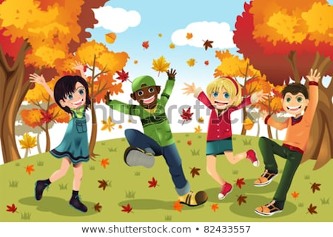

**Community Links and Cultural Capital:**

Links with Diwali and Hanukkah (Come and See)

Christmas links with Reeves Court (Sending Christmas cards to the elderly)

**Links to Fundamental British Values:**

**Democracy:** Provide activities to promote lots of turn-taking and sharing of resources. Daily choice of story book/snack etc.

**Mutual Respect:** Children will acknowledge the differences in religious beliefs, learning about Judaism and Diwali.

**Links to home learning:**

Children will be asked to share their experiences of celebrations at home and with their families.

Library books will be sent home to share each week and a little activity relating to our topic.

**Implementation**

Children will be taught using a combination of adult led activities and input alongside continuous child-initiated learning activities. All assessments will be completed in provision.

**Impact**

Children will gain knowledge about celebrations from a variety of faiths and will be able to link these to their own experiences