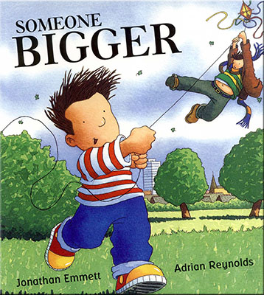 I

**Development Matters Links (Intent)**

(Direct teaching points highlighted, other DM links will be incidentally taught during child-initiated learning time)

|  |
| --- |
| **Making Relationships**  19. Play in a group, extending and elaborating play ideas.  20. Initiate play offer cues to peers to join them.  21. Keep play going by responding to what others are saying or doing. |
| **Managing Feelings and Behaviour**  22. Become aware of own feelings, and know that some actions and words can hurt others’ feelings.  23. Begin to accept the needs of others and take turns and share resources, sometimes with support from others.  24. Show they can tolerate delay when needs are not immediately met, and understand wishes may not always be met.  26. Gain understanding that own actions affect other people. |
| **Self Confidence and Self Awareness**  13. Welcome and value praise for what they have done.  14. Enjoy the responsibility of carrying out small tasks.  15. Become more outgoing towards unfamiliar people and more confident in new social situations. |
| **Listening and attention**  20. Listen to stories with increasing attention and recall.  21. Join in with repeated refrains and anticipate key events and phrases in rhymes and stories.  22. Focus attention- still listen or do but can shift own attention. |
| **Understanding**  13. Show understanding of prepositions.  15. Begin to gain understanding of ‘why’ and ‘how’ questions.  17. Follow a story without pictures or props. |
| **Speaking**  28. Use intonation, rhythm and phrasing to make the meaning clear to others.  31. Use talk in pretending that objects stand for something else in play.  33. Use language to imagine and recreate roles and experiences in play situations.  36. Introduce a story line or narrative into their play. |
| **Moving and Handling**  43. Control a pencil holding it near the point between first two fingers and thumb.  44. Copy some letters.  45. Experiment with different ways of moving.  46. Jump off an object and land appropriately.  47. Negotiate space when playing racing and chasing games, adjust speed or change direction to avoid obstacles.  48. Demonstrate confidence and skill when travelling under, over and through balancing and climbing equipment. |
| **Health and Self-Care**  24. Observe the effects of activity on the body.  30. Keep clean and dry during the day.  32. Show understanding of need for safety when undertaking new challenges, considering and managing some risks.  33. Show understanding of how to transport and store equipment safely. |
| **Reading**  12. Show growing awareness of the way stories are structured.  13. Suggest how a story might end.  14. Listen to stories with increasing attention and recall.  15. Describe main story settings, events and principal characters.  24. Hear and say initial sounds in words. |
| **Writing**  4. Give meaning to marks as they draw, write and paint.  7. Hear and say initial sounds in words. |
| **Number**  25. Realise that not only objects can be counted.  27. Recognise numerals 1-5.  28. Count up to 3or 4 objects saying one number name for each item.  29. Count actions or objects that cannot be moved.  30. Count objects to 10-Begin to count beyond 10.  31. Count out 6 objects from a larger group.  32. Select correct numeral to represent 1-5, then 1-10. |
| **Shape Space and Measures**  17. Show interest in shape by sustained construction activity or by talking about shapes or arrangements.  19. Use shapes appropriately for tasks.  20. Begin to talk about the shapes of everyday objects. |
| **People and Communities**  9. Recognise and describe special times or events for family or friends.  11. Gain knowledge of some of the things that make them unique and can talk about some of the similarities and differences in relation to friends and family. |
| **The World**  18. Talk about why things happen and how things work. |
| **Technology**  7. Show skill in making toys work by pressing parts or lifting flaps to achieve effects such as sound, movements or new images.  8. Know that information can be retrieved from computers. |
| **Exploring and Using Media and Materials**  23. Begin to build a repertoire of songs and dances.  24. Explore the different sounds of instruments.  27. Gain understanding that different media can be combined to create different effects. |
| **Being Imaginative**  12. Build stories around toys e.g. farm animals needing rescue from an armchair ‘cliff’.  13. Use available resources to create props to support role-play.  14. Capture experiences and responses with a range of media, such as music, dance, paint and other materials or words.  15. Create simple representations of events, people and objects.  18. Introduce a storyline or narrative into their play.  19. Play alongside other children who are engaged in the same theme.  20. Play co-operatively as part of a group to develop and act out a narrative. |

**Links to home learning:**

Children to take home and bring in favourite books to share with their classmates and families.

Activities set on Seesaw related to the topic for the children to complete at home.

**Community Links and Cultural Capital:**

-Meet the Muslim Mother’s Day competition.

**-**World Book Day

**Key Texts to be used:**

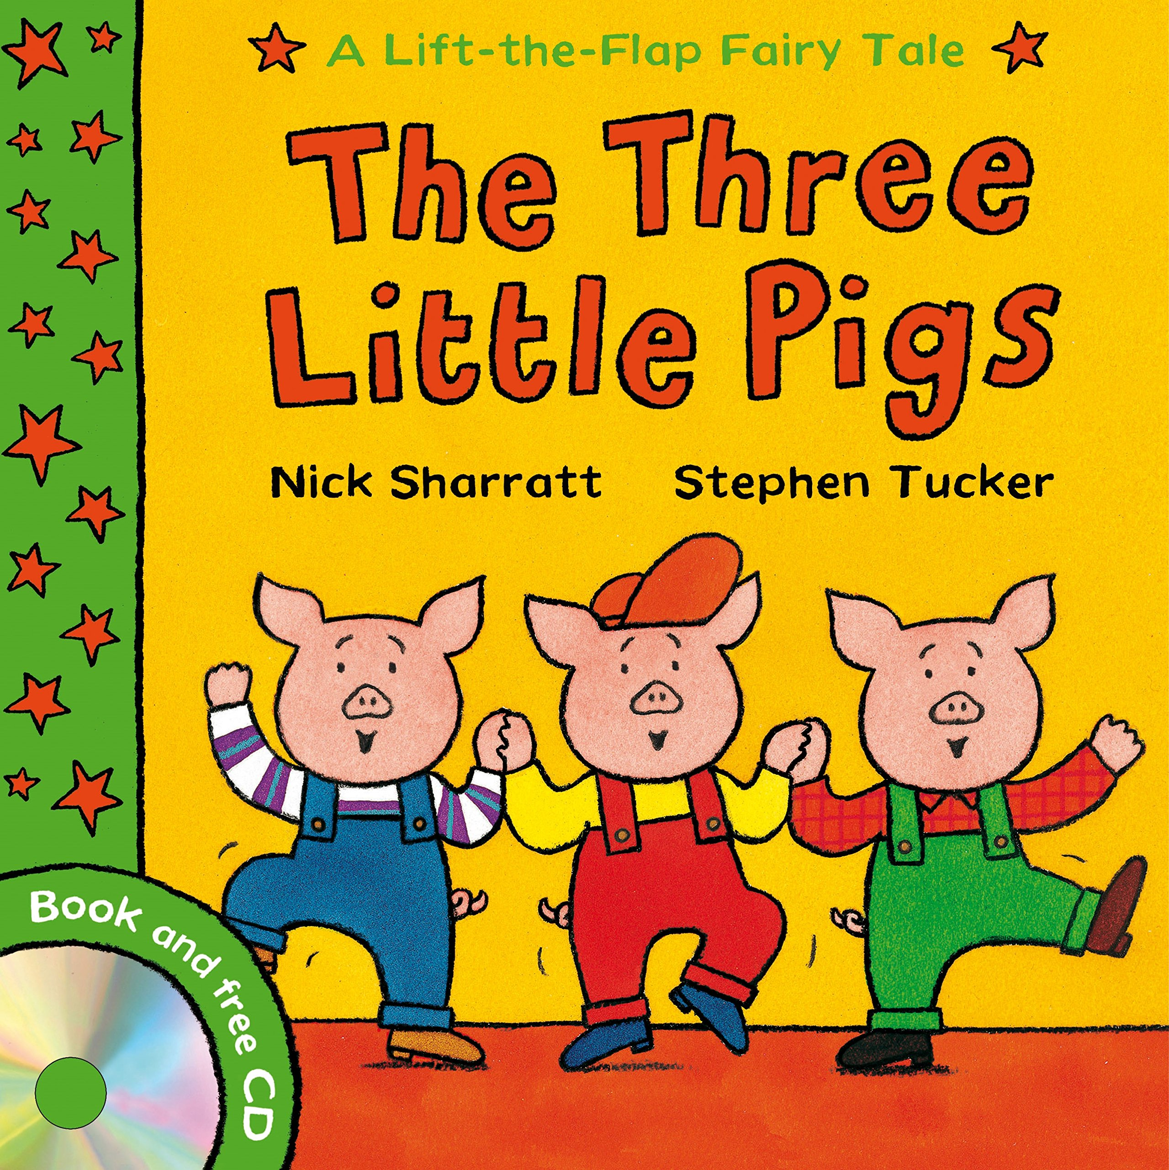

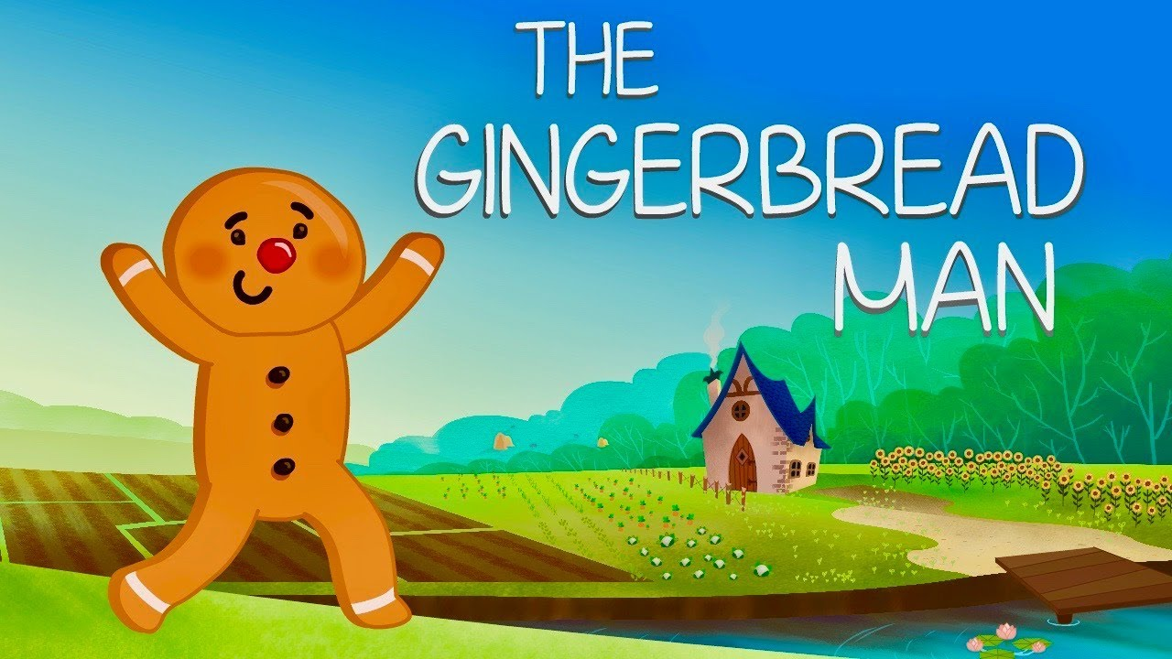

**Spring Term 2**

**We Love Books**



**Links to Fundamental British Values:**

**Mutual Respect-** Encourage children to share stories of their home that reflect the values and diversity of their experiences.

**Democracy-** Encourage children to bring in stories from home and ask the children to vote showing hands for the story they would like to listen to each day.

**Rule of law-** Talk to the children about the actions of characters in stories and the consequences, The Big bad wolf, The Gingerbread Man etc.

**Individual Liberty-**Group discussions about the stories we have shared. Allow the children to voice their own feelings and understand they are free to have their own opinion.

**Impact**

Children will develop a love of stories and books to help them to become confident readers in the future. They will enjoy reading and share their enjoyment with others.

**Implementation**

Children will be taught using a combination of adult led activities and input alongside continuous child-initiated learning activities. All assessments will be completed in provision.