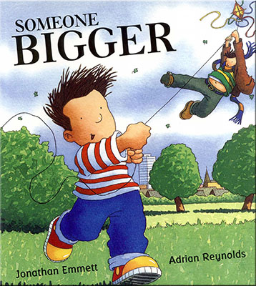 I

**Community Links and Cultural Capital:**

Learning about other religions and cultures.

**Links to home learning:**

Library books to be sent home weekly for children to share at home.

Activities set on Seesaw related to the topic for the children to complete at home.

**Development Matters Links (Intent)**

(Direct teaching points highlighted, other DM links will be incidentally taught during child-initiated learning time)

|  |
| --- |
| **Making Relationships**  23. Initiate conversations, attend to and takes account of what others say.  24. Explain own knowledge and understanding, and ask appropriate questions of others. |
| **Managing Feelings and Behaviour**  23. Begin to accept the needs of others and take turns and share resources, sometimes with support from others.  24. Show they can tolerate delay when needs are not immediately met, and understand wishes may not always be met.  26. Gain understanding that own actions affect other people.  27. Become aware of boundaries set, and of behaviour expectations in the setting. |
| **Self Confidence and Self Awareness**  18. To speak to others about own needs, wants, interests and opinions. |
| **Listening and attention**  22. Focus attention- still listen or do but can shift own attention.  23. Follow directions (if not intently focused on own choice of activity)  24. Maintain attention, concentrate and sit quietly during appropriate activity. |
| **Understanding**  16. Respond to instructions involving a two part sequence. |
| **Speaking**  25. Use talk to connect ideas, explain what is happening and anticipate what might happen next, recall and relive past experiences.  26. Questions why things happen and give explanations.  27. Use a range of tenses.  28. Use intonation, rhythm and phrasing to make the meaning clear to others.  32. Extend vocabulary, especially by grouping and naming, exploring the meaning and sounds of new words. |
| **Moving and Handling**  39. Catch a large ball.  49. Show increasing control over an object in pushing, patting throwing, catching or kicking it.  50. Use simple tools to effect change to materials.  51. Handles tools, objects, construction and malleable materials safely.  52. Show preference for a dominant hand.  53. Use anticlockwise movement and retrace vertical lines.  54. Begin to form recognisable letters. |
| **Health and Self-Care**  29. Eat a healthy range of foodstuffs and understand the need for variety in food.  31. Gain understanding of good practices with regard to exercise, eating, sleep and hygiene.  32. Show understanding of the need for safety when undertaking new challenges, considering and managing some risks.  33. Show understanding of how to transport and store equipment safely. |
| **Reading**  20. Show knowledge that information can be relayed in the form of print.  22. Show they know that print carries meaning and in English is read left to right, top to bottom  23. Continue a rhyming string.  24. Hear and say initial sounds in words.  25. Segment sounds in simple words and blend them together.  26. Link sounds to letters, name and sound letters of the alphabet. |
| **Writing**  6. Continue a rhyming string.  7. Hear and say the initial sound in words.  8. Segment the sounds in simple words and blend them together.  9. Links sounds to letters, naming and sounding the letters of the alphabet. |
| **Number**.  20. Compare two groups of objects and say when they have the same number.  21. Show an interest in number problems.  22. Separate a group of 3 or 4 objects in different ways, recognising the total is still the same.  30. Count objects to 10-Beginning to count beyond 10.  32. Select correct numeral to represent 1-5, then 1-10.  34. Estimate how many objects they can see and check by counting them.  36. Find total number of items in two groups by counting all of them. |
| **Shape Space and Measures**  21. Begin to use mathematical names for solid 3D shapes and flat 2D shapes.  22. Select a particular names shape.  24. Order 2 or 3 items by length or height.  26. Use familiar objects and common shapes to create and recreate patterns and build models. |
| **People and Communities**  9. Recognise and describe special times or events for family or friends.  11. Gain knowledge of some of the things that make them unique and can talk about some of the similarities and differences in relation to friends or family. |
| **The World**  17. Talk about some of the things they have observed such as plants, animals, natural and found objects.  19. Develop an understanding of growth, decay and changes over time.  20. Show care and concern for living things and the environment. |
| **Technology**  8. Know that information can be retrieved from computers. |
| **Exploring and Using Media and Materials**  25. Explore what happens when they mix colours.  26. Experiment to create different textures.  28. Manipulate materials to achieve a planned effect.  29. Construct with a purpose in mind, using a variety of resources. |
| **Being Imaginative**  16. Initiate new combinations of movement or gesture in order to express and respond to feelings, ideas and experiences.  17. Choose particular colours to use for a purpose. |

**Key Texts to be used:**

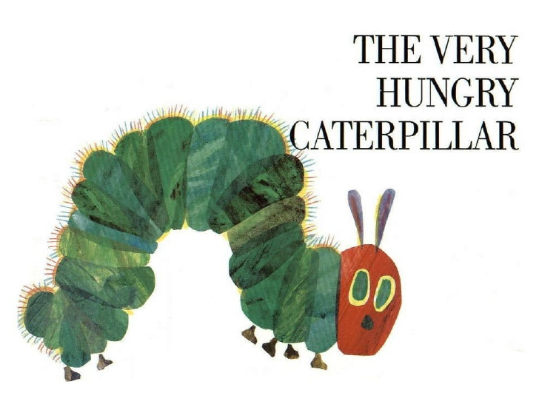 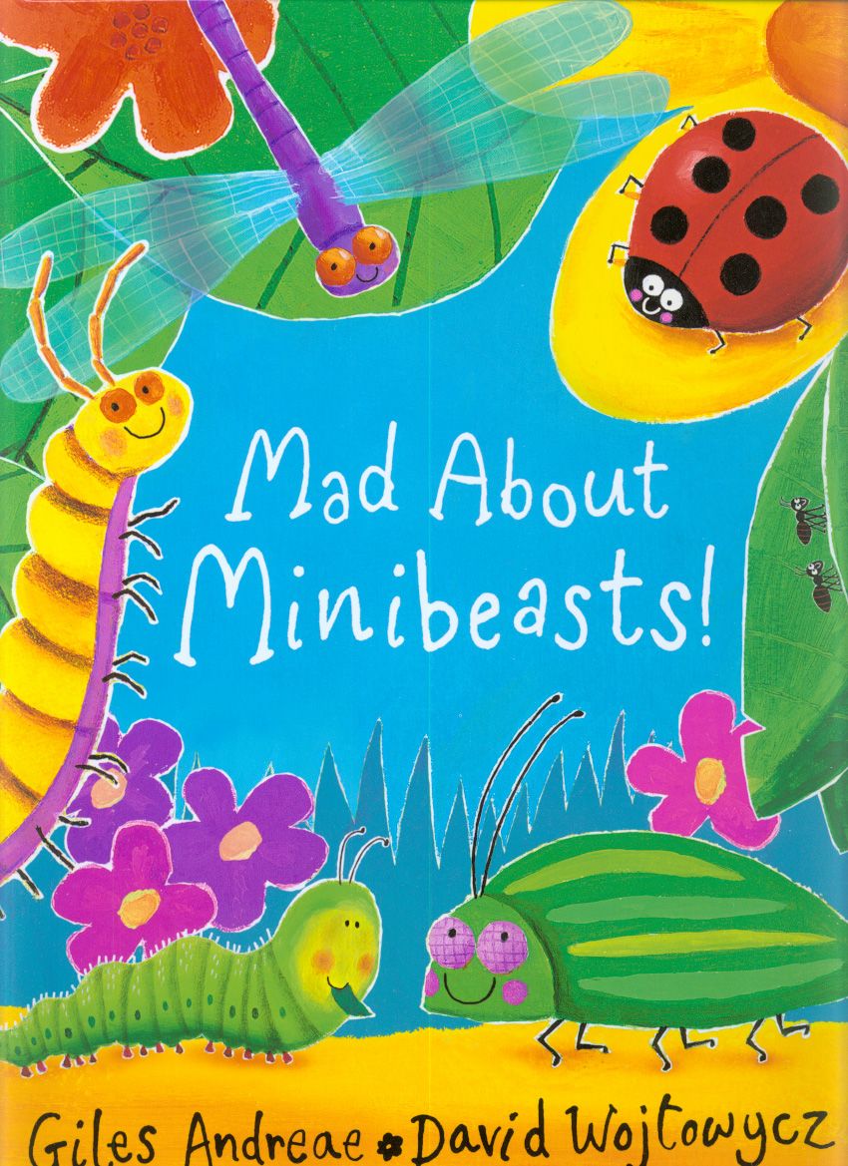

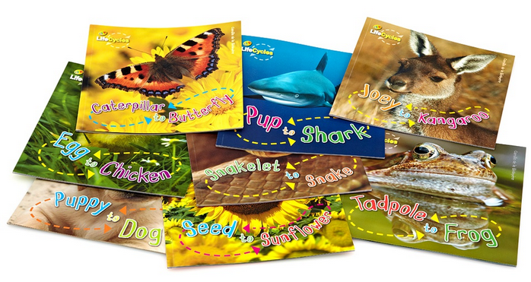 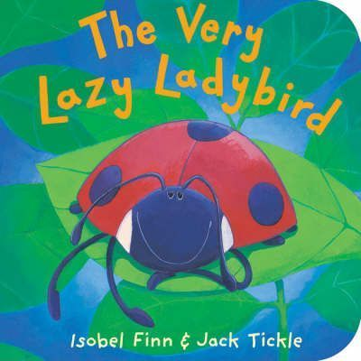

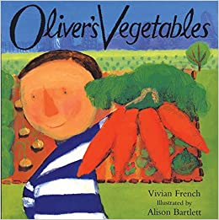 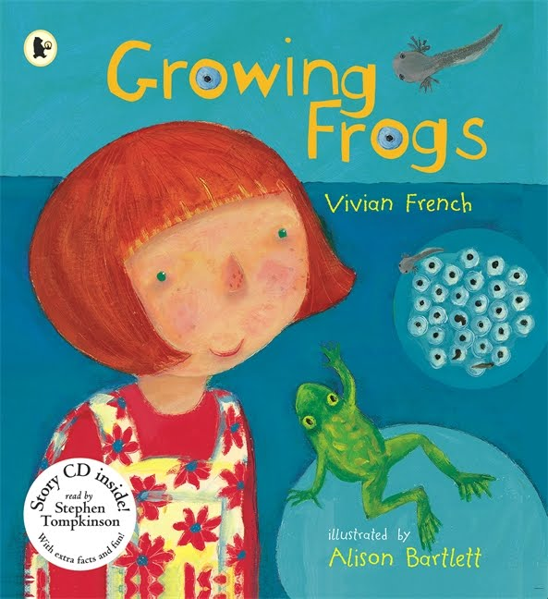

**Summer Term 1**

**Life cycles and growth**

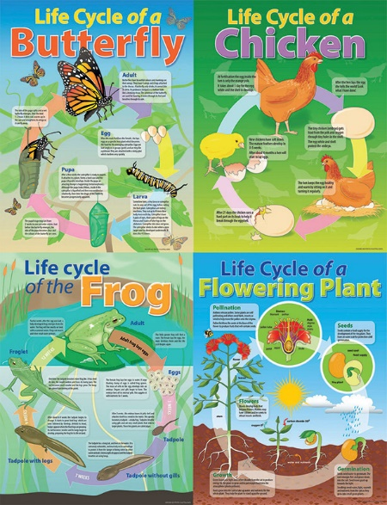

**Links to Fundamental British Values:**

**Democracy:** We encourage children to make choices and decisions, take turns and collaborate during play. We ensure they value each other’s views and opinions and provide opportunities to talk about feelings.

**Individual liberty:** We encourage children to develop independence and to think for themselves.

**Rule of law:** We work with children to develop rules and ensure they understand that rules apply to everyone. We help children understand right from wrong. We encourage children to make the right choices to keep our class a safe and happy place to learn.

**Mutual respect and tolerance:** We teach the children about the world they live in. We provide the children with an understanding and respect for their own and other cultures, exploring similarities and differences between traditions, practices and customs.

**Democracy-**

**Rule of law-**

**Individual Liberty-**

**Impact**

Children will become knowledgeable about the life cycles of plants and creatures. They will know how to grow their own plants and show care and concern for living things and their environment.

**Implementation**

Children will be taught using a combination of adult led activities and input alongside continuous child-initiated learning activities. All assessments will be completed in provision.