 I

**Community Links and Cultural Capital:**

EYFS visit to imagine that

Learning about other religions and cultures.

Spanish week.

Fathers day

**Links to home learning:**

Library books will be sent home to share each week and a little activity set on Seesaw relating to our topic.

**Development Matters Links (Intent)**

(Direct teaching points highlighted, other DM links will be incidentally taught during child-initiated learning time)

**Making Relationships**

23. Initiate conversations, attend to and takes account of what others say.

24. Explain own knowledge and understanding, and ask appropriate questions of others.

**Managing Feelings and Behaviour**

25. Try to adapt behaviour to different events, social situations and changes in routines.

26. Gain understanding that own actions affect other people.

27. Aware of boundaries set, and of behaviour expectations in the setting.

**Self Confidence and Self-Awareness**

15.Become more outgoing towards unfamiliar people and more confident in new situations.

18. To speak to others about own need, wants, interests and opinions.

**Listening and Attention**

24. Maintain attention, concentrate and sit quietly during appropriate activity.

**Speaking**

25. Use talk to connect ideas, explain what is happening and anticipate what might happen next, recall and relive past experiences.

26. Questions why things happen and give explanations.

27. Use a range of tenses.

28. Use intonation, rhythm and phrasing to make the meaning clear to others.

32. Extend vocabulary, especially by grouping and naming, exploring the meaning and sounds of new words.

34. Link statements and stick to a main theme or intention.

**Understanding**

16. Respond to instructions involving a two part sequence.

18. Listen and respond to ideas expressed by others in conversation and discussion.

**Moving & Handling**

39. Catch a large ball.

49. Show increasing control over an object in pushing, patting throwing, catching or kicking it.

50. Use simple tools to effect change to materials.

51. Handles tools, objects, construction and malleable materials safely.

52. Show preference for a dominant hand.

53. Use anticlockwise movement and retrace vertical lines.

54. Begin to form recognisable letters.

**Health & Self-Care**

29. Eat a healthy range of foodstuffs and understand the need for variety in food.

33. Show understanding of how to transport and store equipment safely.

34. Practice appropriate safety measures without direct supervision.

**Reading**

20. Show knowledge that information can be relayed in the form of print.

22. Show they know that print carries meaning and in English is read left to right, top to bottom

23. Continue a rhyming string.

24. Hear and say initial sounds in words.

25. Segment sounds in simple words and blend them together.

26. Link sounds to letters, name and sound letters of the alphabet.

**Writing**

6. Continue a rhyming string.

7. Hear and say the initial sound in words.

8. Segment the sounds in simple words and blend them together.

9. Links sounds to letters, naming and sounding the letters of the alphabet.

10. Use some clearly identifiable letters to communicate meaning, represent some sounds correctly and in sequence.

11. Write own name.

**Numbers**

21. Show an interest in number problems.

30. Count objects to 10-Beginning to count beyond 10.

32. Select correct numeral to represent 1-5, then 1-10.

34. Estimate how many objects they can see and check by counting them.

36. Find total number of items in two groups by counting all of them.

37. Say the number that is one more than a given number.

38. Find one more or one less from a group of 5 objects then 10 objects.

**Shape Space and Measures**

25. Order 2 or 3 items by weight or capacity.

27. Use everyday language related to time.

29. Order and sequence familiar events.

30. Measure short periods of time in simple ways.

**People and Communities**

11. Gain knowledge of some of the things that make them unique and can talk about some of the similarities and differences in relation to friends or family.

12. Enjoys joining in with family customs and routines.

**The World**

20. Show care and concern for living things and the environment.

21. Looks closely at similarities, differences, pattern and change.

**Technology**

8. Know that information can be retrieved from computers

9. Complete a simple program on a computer.

**Exploring and Using Media and Materials**

28. Manipulate materials to achieve a planned effect.

30. Use simple tools and techniques competently and appropriately.

**Being Imaginative**

18. Introduce a storyline or narrative into their play.

19. Play alongside others who are engaged in the same theme.

20. Play co-operatively as part of a group to develop and act out a narrative.

**Links to Fundamental British Values:**

**Democracy:** We encourage children to make choices and decisions, take turns and collaborate during play. We ensure they value each other’s views and opinions and provide opportunities to talk about feelings.

**Individual liberty:** We encourage children to develop independence and to think for themselves.

**Rule of law:** We work with children to develop rules and ensure they understand that rules apply to everyone. We help children understand right from wrong. We encourage children to make the right choices to keep our class a safe and happy place to learn.

**Mutual respect and tolerance:** We teach the children about the world they live in. We provide the children with an understanding and respect for their own and other cultures, exploring similarities and differences between traditions, practices and customs.

**Summer Term 2**

Summertime and space



**Key Texts to be used:**

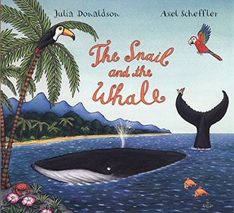 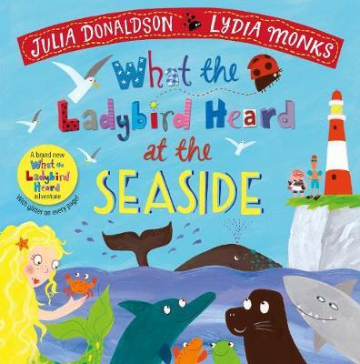

 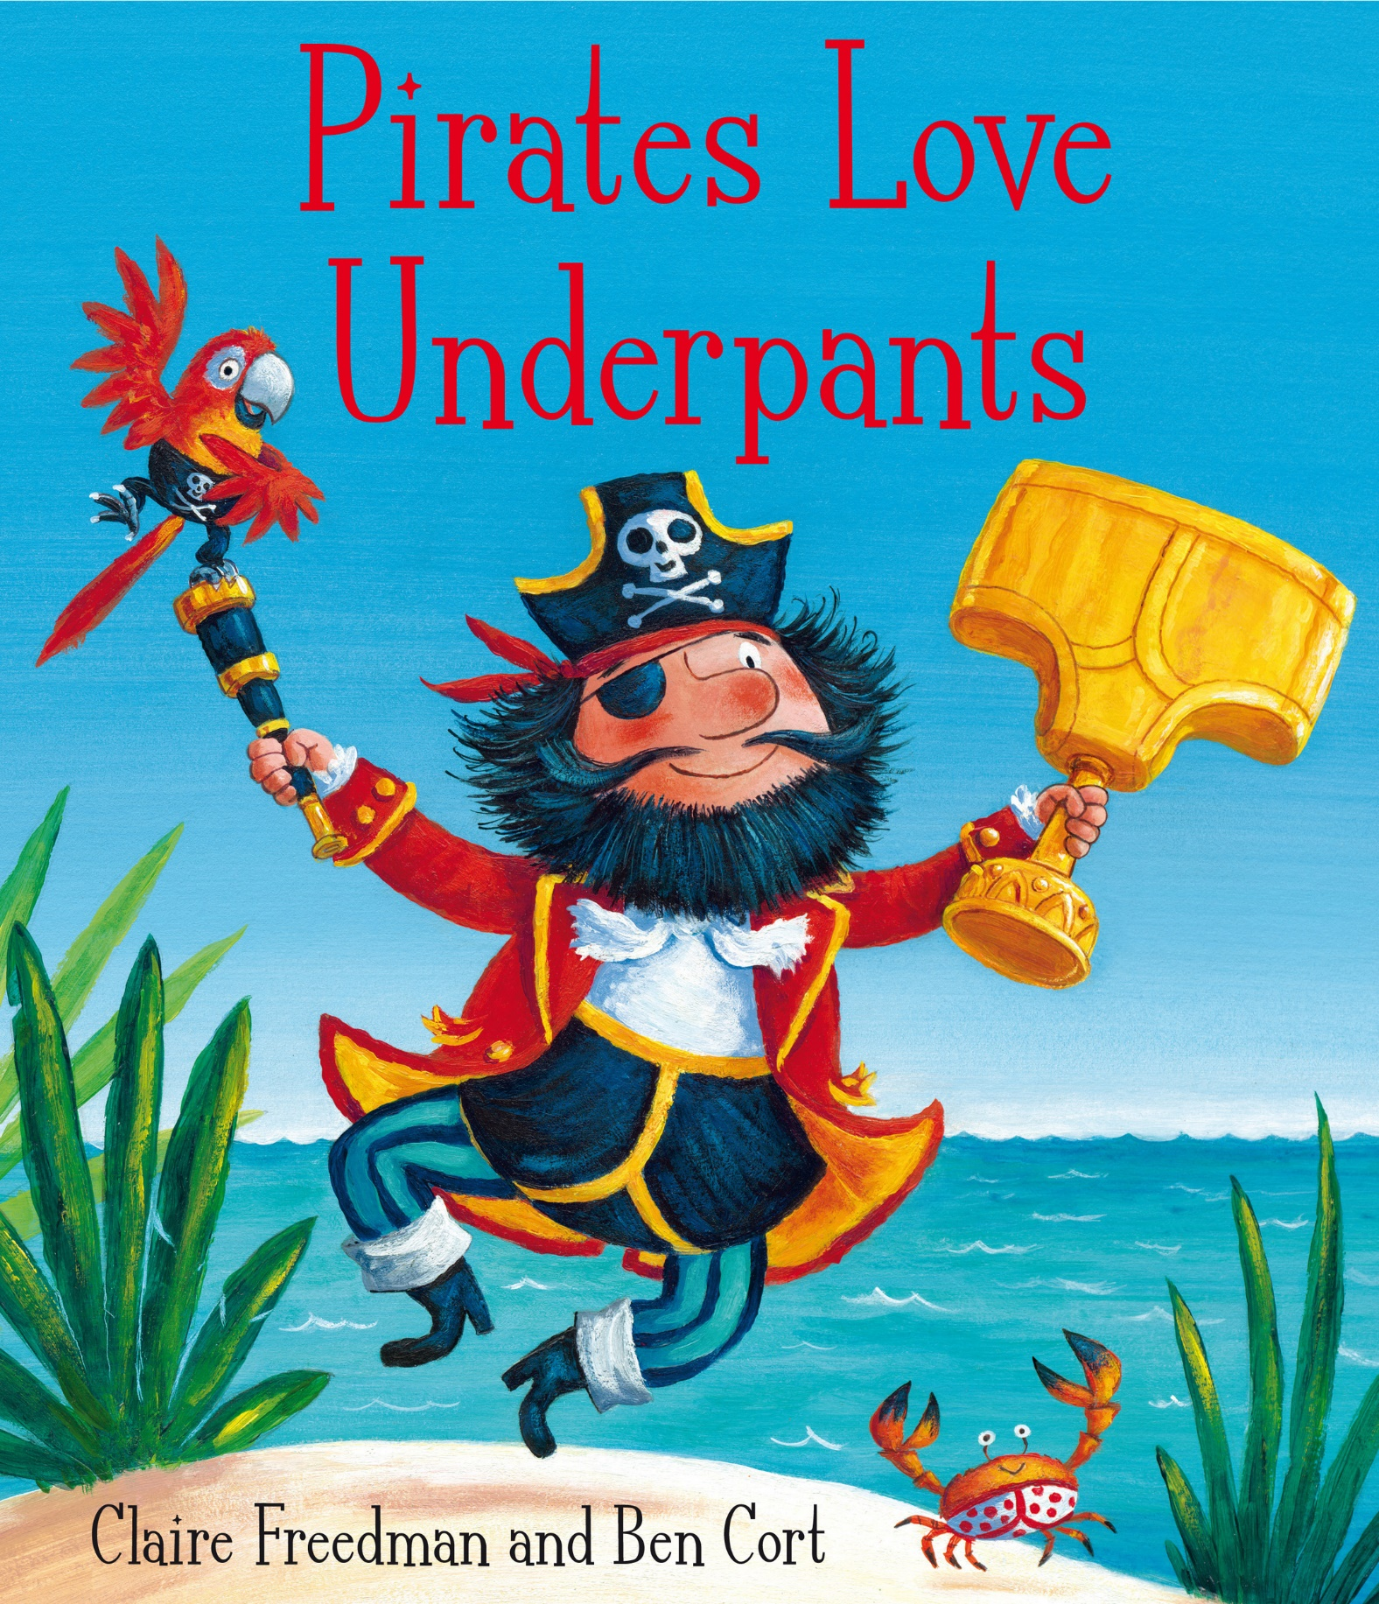

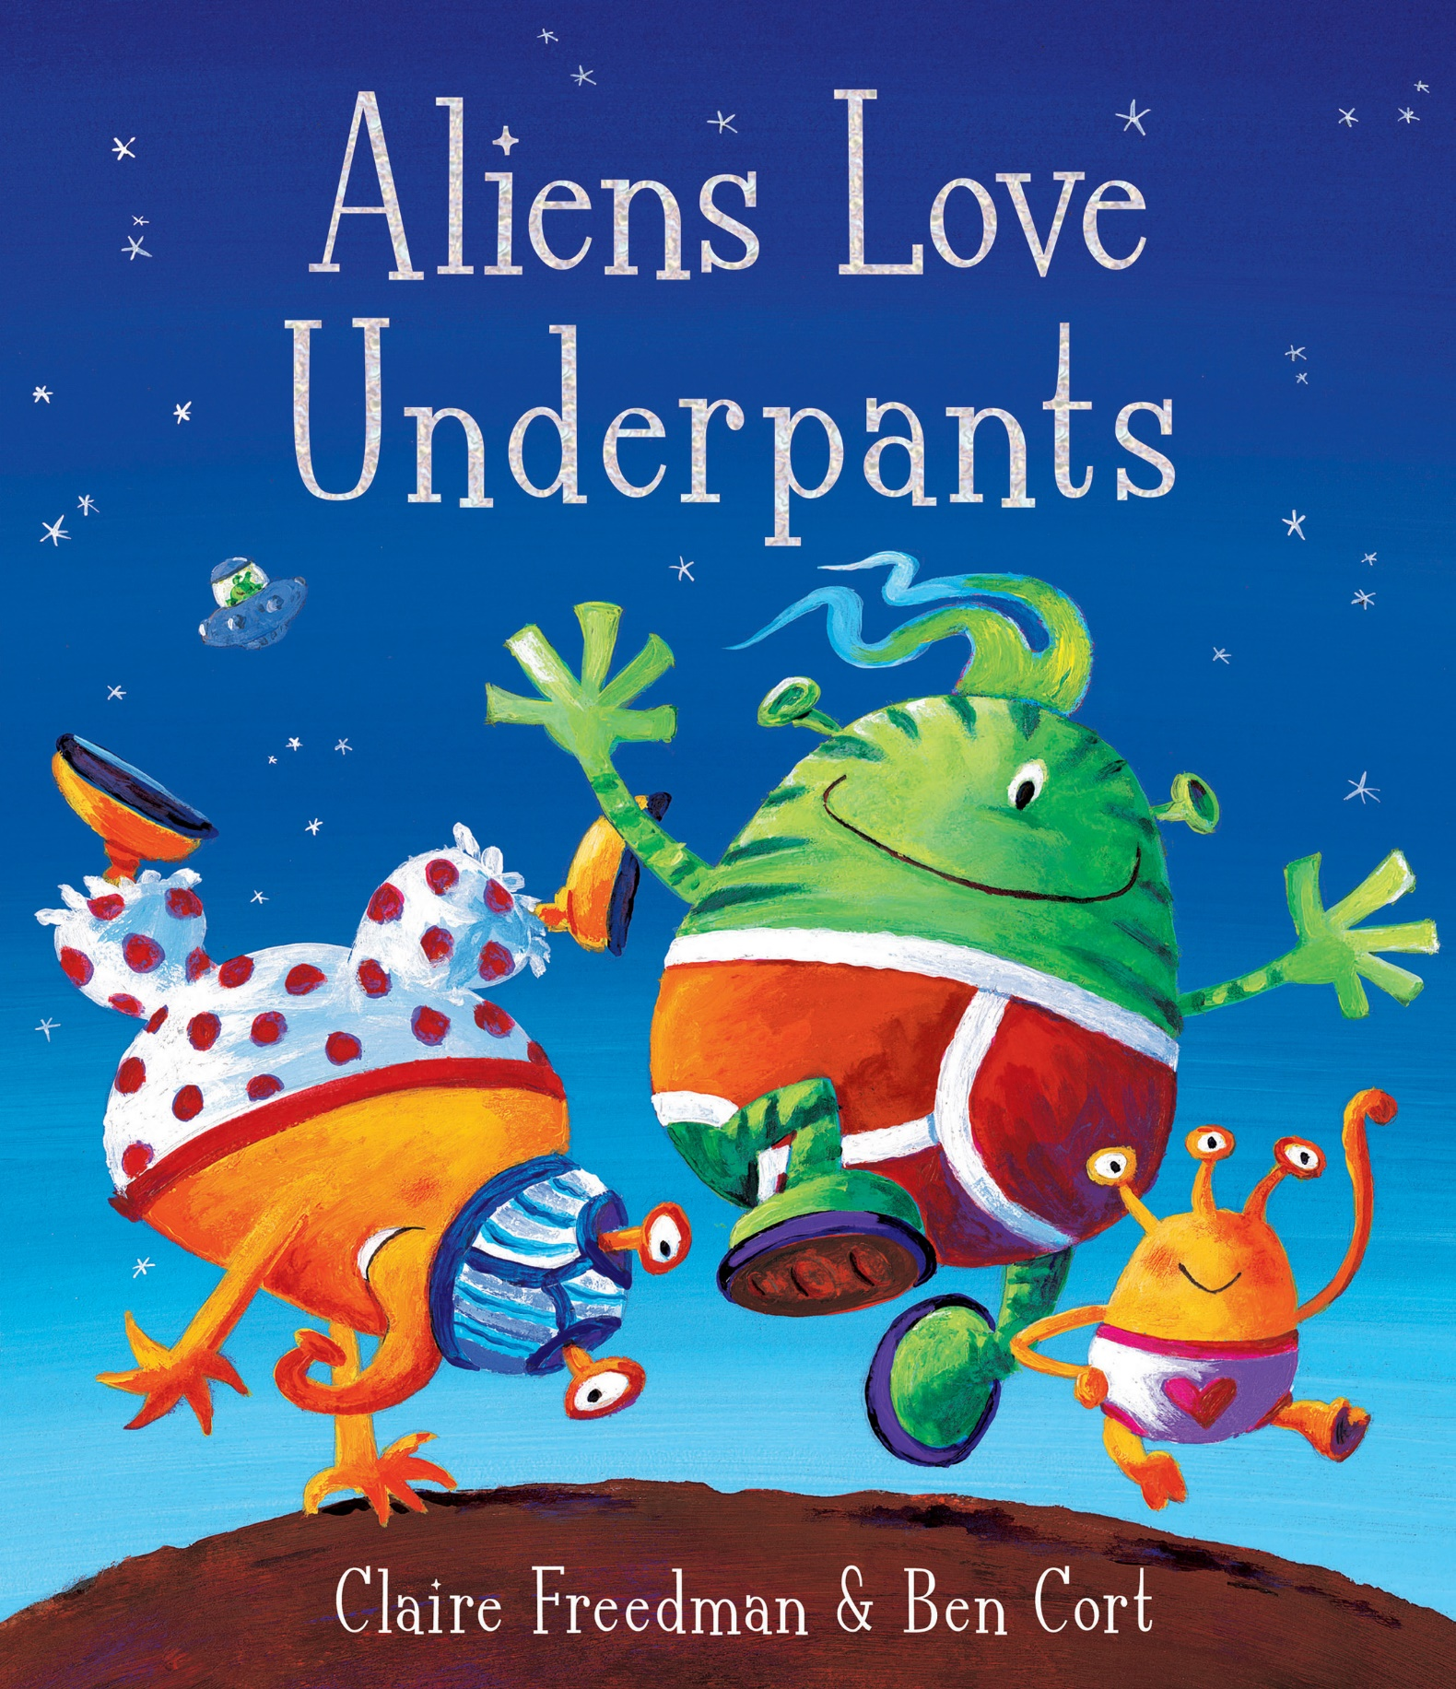 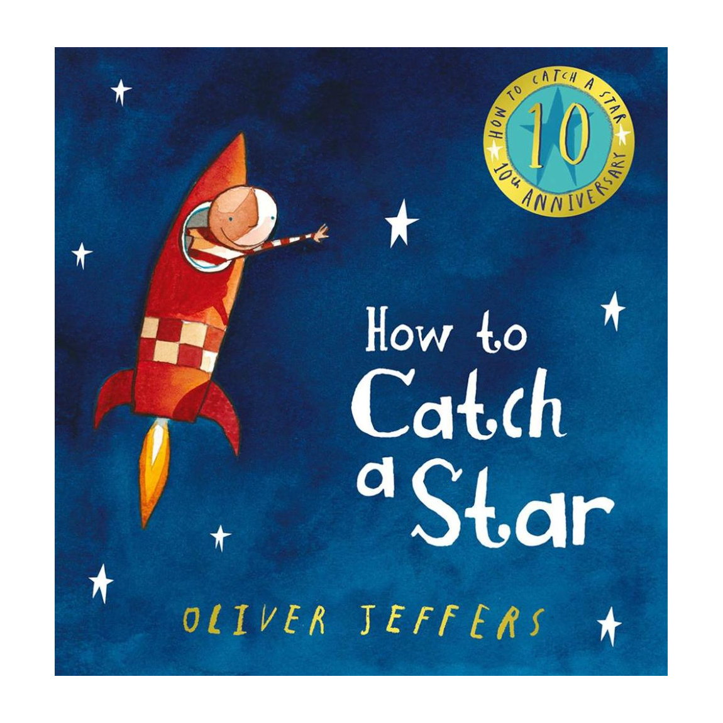

**Implementation**

Children will be taught using a combination of adult led activities and input alongside continuous child-initiated learning activities. All assessments will be completed in provision.

**Impact**

Children will become knowledgeable about the season of summer and how people enjoy the nice weather. They will gain an understanding of life under the sea and all the different planets and stars in Space.