

**History**

Stone Age to Iron Age

Looking at Ancient Britain and how they survived in this era. Stonehenge: why is it important?

**Maths**

Place value, addition

and subtraction, problem solving,

Fluency: Adding and subtracting mentally

**English - Reading**

**Fiction**: Our class reader is ‘Hunters, Gatherers & Woolly Mammoths’. We will focus on developing our VIPERS skills for reading - Vocabulary, Inference, Prediction, Explaining, Retrieval and Summarising.

**Non-Fiction:** We will use non-fiction books and appropriate websites to learn about the Stone Age, Bronze Age and Iron Age

**Half Termly Value: Respect**



**PE**

Football

Gymnastics

**Science**

**Forces and Magnets**

Compare how things move on different surfaces. Understand that some forces need contact between two objects, but magnetic forces can act at a distance. Observe how magnets attract or repel each other and attract some materials and not others.





**ART**

Prehistoric cave paintings. Stonehenge paintings.

**Linked to English and History**

**English – Writing & SPaG**

**Narrative** – Story

Work based on Stone Age Boy by Satoshi Kitamura

**Poems** – Poems about seasons

**Handwriting** - correct letter formation and leads into cursive writing



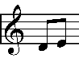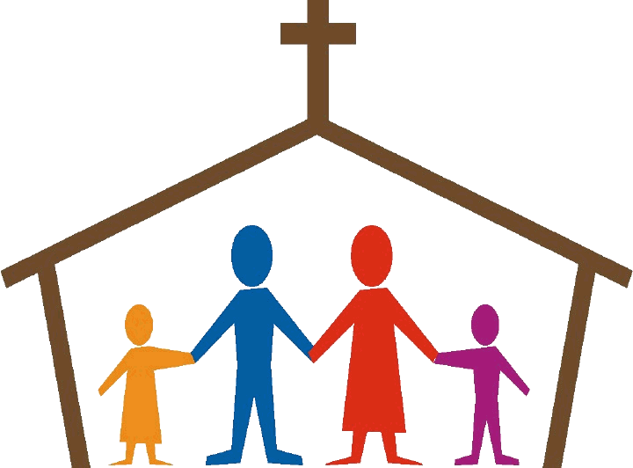

**RE**

Homes: Thinking about the homes that we live and what makes it. Jesus’ family.

Promises: Linking the promises made in everyday life to those made at Baptism

**Music**

Let your spirit fly

Prepare and perform songs for Harvest Community afternoon



**Home-school and community links**

The children will contribute to school’s ‘community afternoon’ learning and performing songs and donating to those in need.

Parents/family members will be invited into school during the school day to play times table games and activities with the children.



**Computing**

**Journey inside a computer-** Computer parts- Inputs and Outputs.



**PSHE**

Being Me in My World

Understanding my place in the class, school and global community as well as devising Learning Charters

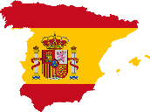

**Spanish**

A new start

Getting to know you

Numbers, Colours

**WOW Experience!**

We will have our very own ‘Baptism’: Father Martin, guests, invitations, hymns, prayers, godparents…even party food!