Year | Pupil | Year | Pupil
First Steps | Charlotte & Sawmia | Year 3 | Harry & Maggie
Reception | Amelie & Eleanor | Year 4 | Max & Lillie - May
Year 1 |  | Year 5 | Elisha & Charlie
Year 2 | Isla & Natan | Year 6 | Jude & Alex

Year | Pupil | Year | Pupil
First Steps | Zara | Year 3 | Noah
Reception | Samuel | Year 4 | Tye
Year 1 |  | Year 5 | Bobby
Year 2 | John | Year 6 | Joshua

Reception | 91.03% | Year 4 | 91.03%
Year 1 | 87.04% | Year 5 | 97.78%
Year 2 | 97.41% | Year 6 | 99.60%
Year 3 | 88.49% | Overall school attendance | 93.19%

We have had the following birthdays over the last two weeks
Year 1 - Zac
Year 2 – Isabella & Alex
Year 3 – Shanraj, Harrison, Emma & Harry
Year 4 - Lucy Mia & Serena
Year 6 Charley
Wishing you all a fantastic birthday!!

News

Year 5 and 6 will be attending the Liverpool Philharmonic on Tuesday 15th March. The cost of this trip is £15.00. Please make payment on the app or send onto school.

Friday will be an own clothes day for the Easter bingo – more information will be sent our next week.

This week the children loved having the Science Boffins come into school. The children had a fantastic day and loved the rocket launch. We thank everyone who contributed to make this day happen.

We would like to thank everyone who donated to the Ukrainian appeal. The generosity of our school community was overwhelming. The donations are now on their way to helping those in need during this difficult time. For some of our school community this is a very personal situation, so it was lovely to see the support.

Donation centres we helped.

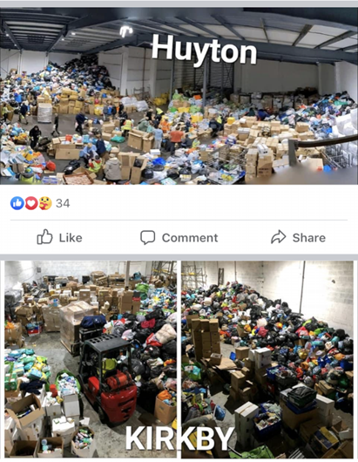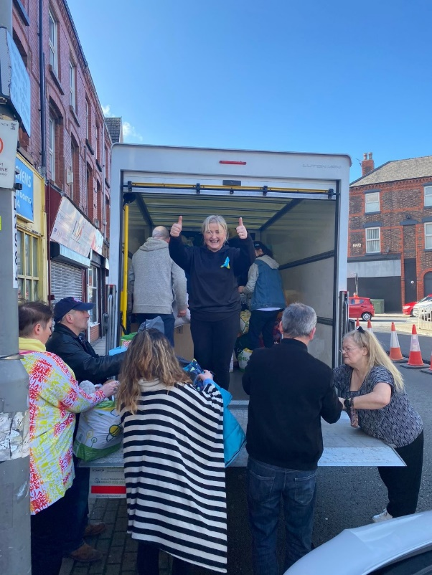

Our donations

